Architecture Mips project

The project is about division and find which program is faster with div or without

First thing we made three codes first one is manual division second code is using division instruction the third code is the improvement code, enhancement

4.The CPU time of the first two codes will be in the table based in the instruction count from the mars compiler
Here is the formula of the CPU time = 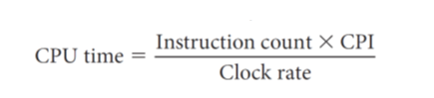
Cpi=1 (assume )
Clock rate =1GHz

Inputs | Method | Instruction count | CPU time
(100,7) | Manual | 476 | 476 ns
(20,4) | Manual | 472 | 472 ns
(100,7) | Div | 45 | 45 ns
(20,4) | Div | 45 | 45 ns

Average manual | 474
Average div | 45
5.Manual program is 10.5333 slower than program div
So div program is faster than manual because div is instruction is an instruction that can do division in one step or few steps to get the result not like manual the manual do shift and adding check if subtraction is possible and a lot of steps and repeat 32 times to get result

6.The alu(sub) instruction In the manual program consume most of the CPU time

7.we can improve the algorithm by reducing unnecessary operations and using registers more efficiently
Input 100,7 the CPU time 337
The first algorithm is 1.41 slower than the enhanced

